Scanner : Present inside util package

Scanner s1=new Scanner (System.in) --- This allows to take input from console and store it into program.

Int a=s1.nextInt();

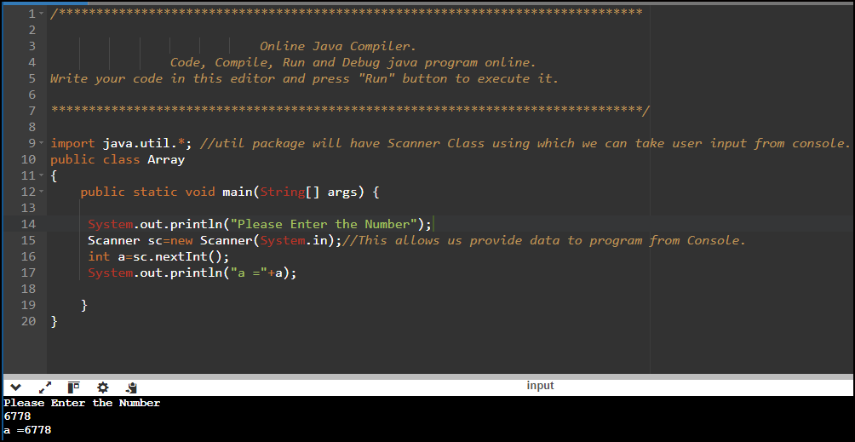

<https://onlinegdb.com/9k3FHrrwG>

Array has a property length which we can use calculate the length of the array

int [] ar=new int[6]

ar.length --This will return the value as 6

1-D Array Example

<https://onlinegdb.com/KEBl7buX4>

2-D Regular Array Example

<https://onlinegdb.com/v2RC1NVmY>

2-D Jagged Array:

<https://onlinegdb.com/RYYws-EYL>

3-D Regular Array :

<https://onlinegdb.com/XrKzetK2i>

3-D Jagged Array :

<https://onlinegdb.com/sUTCaA3il>

Buffer Overrun:

Using the memory block that is not declared but trying to using it.

Consider we have defined an array of size 5 and tried Accessing the 6 block then we can consider that as Buffer Overrun.

int a [] =new int [5];

a [6] =10 //Trying to access the block out of the range ---Buffer Overrun

In Java there will be no Problem will Buffer Overrun as the Arrays are guarded with Boundary's.

If we try access any other location excluding the Array Boundary it would result in Runtime Exception ---- ArrayIndexOutofBoundsException.

Ex :

<https://onlinegdb.com/fDWuNAJAz>

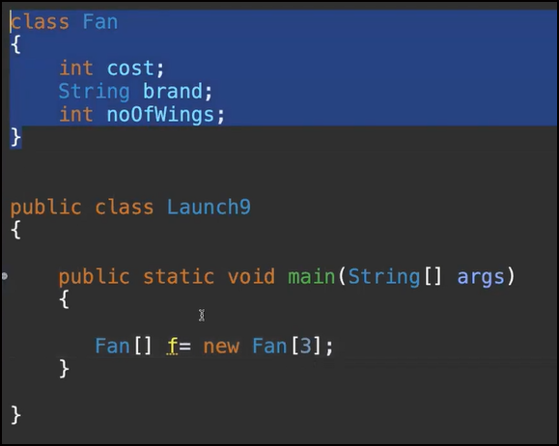

Created an Array where it can store Fan Object.

For Object the Default value is null.

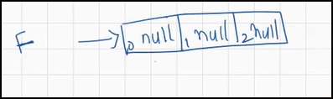

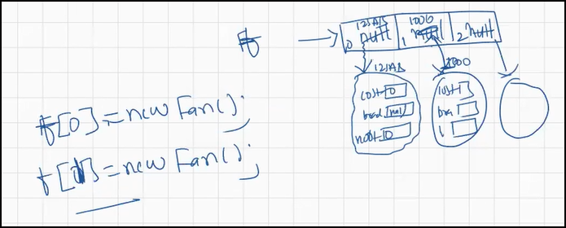

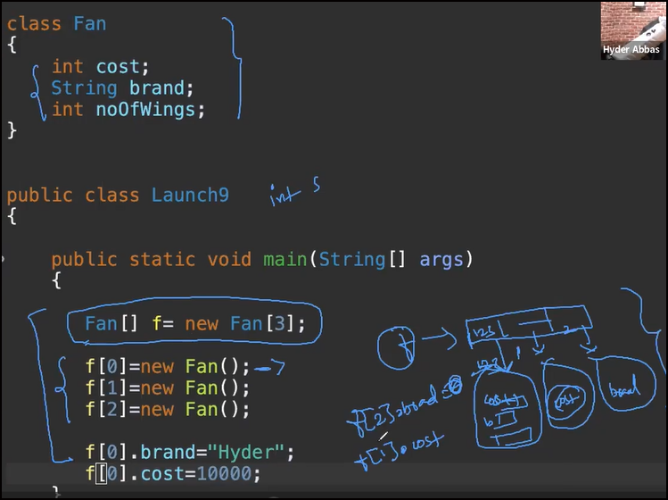

Disadvantages of Array:

* It can store only Homogenous data.
* Memory of Array is Fixed in Size (It cannot either grow/Shrink).
* Arrays demand Contiguous memory locations.

Different ways to define Array :

int a[]=new int[4];

Int [] a=new int[4];

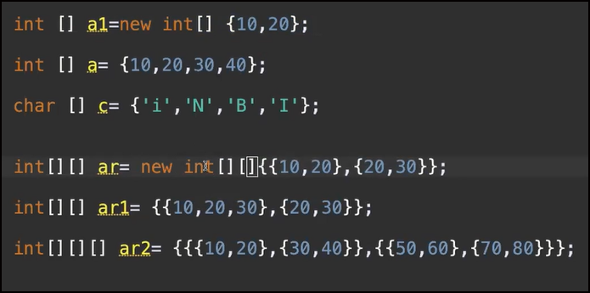

Enhance For Loop :

<https://onlinegdb.com/tfnUrcX9R>